Akosua with Gye Nyame Back
https://www.amazon.com/dp/B0H58WLSV2?th=1&psc=1

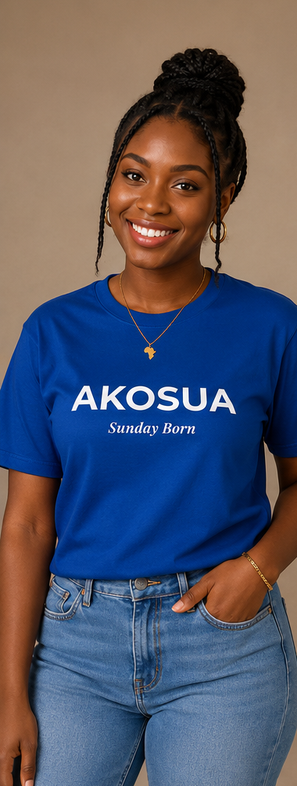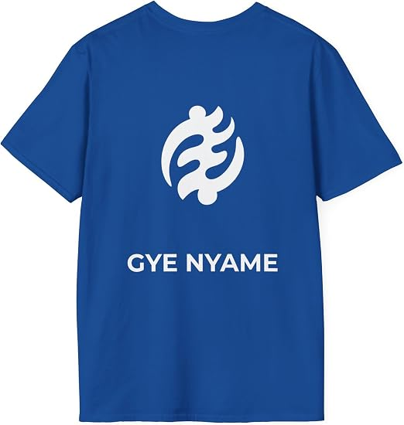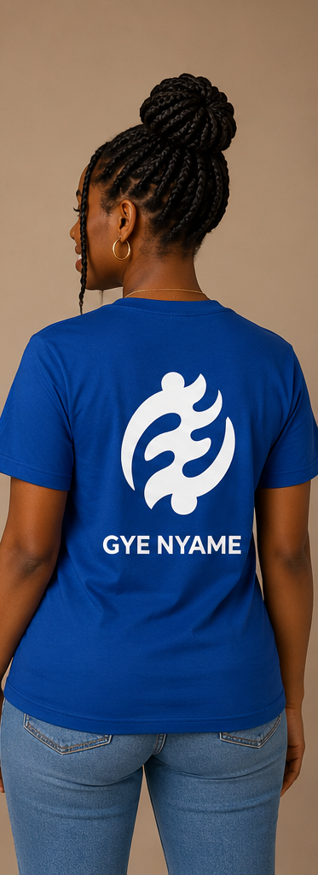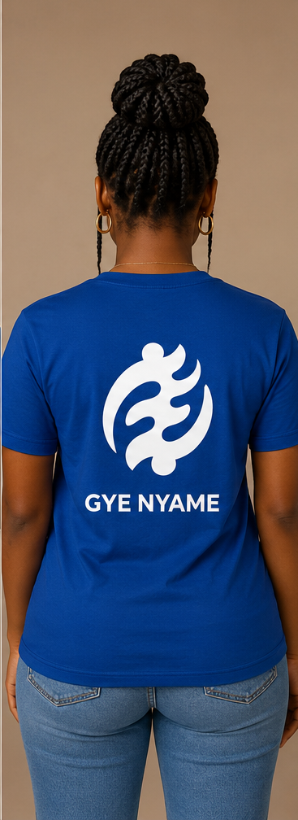
Akosua with Sankofa Back
https://www.amazon.com/dp/B0H5925J6Y?th=1&psc=1

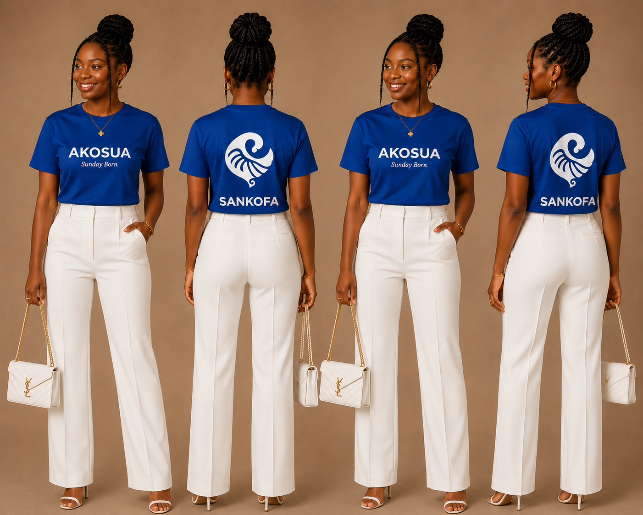
Akosua onesie
https://www.amazon.com/dp/B0H5D9SRCQ?th=1&psc=1

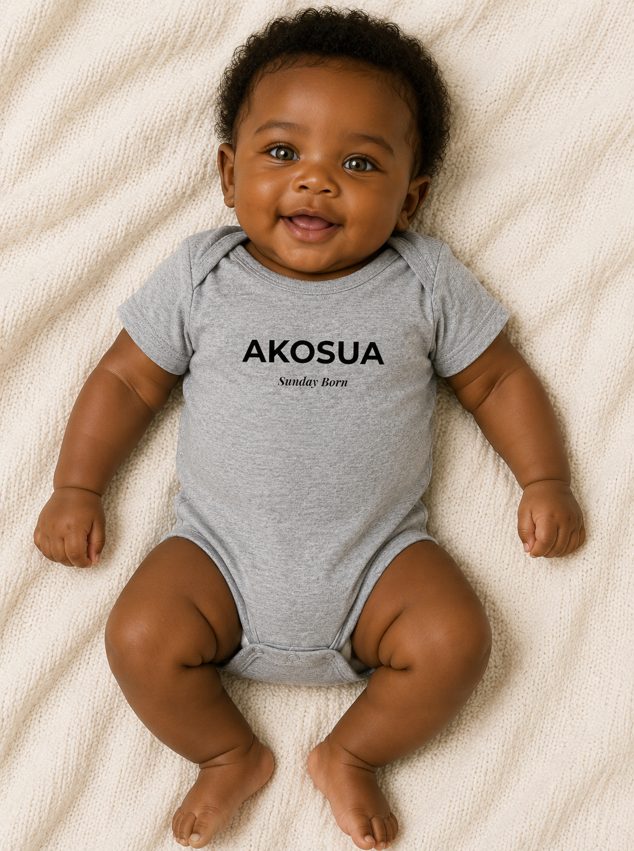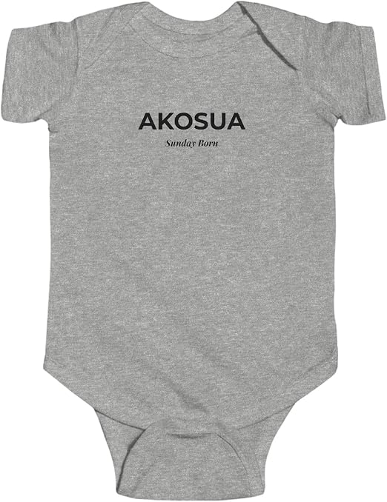
Kwasi onesie
https://www.amazon.com/dp/B0H5CZNV1P?th=1&psc=1
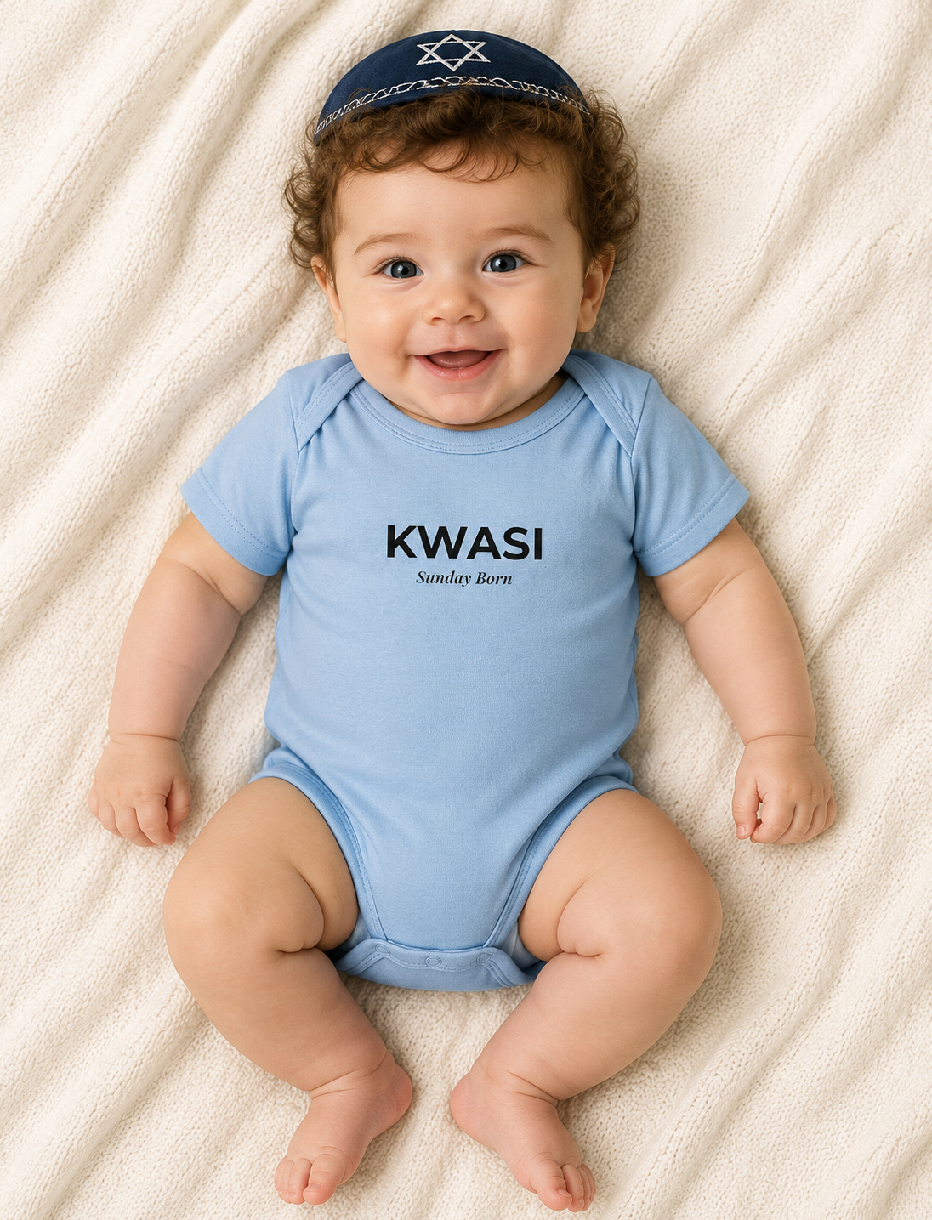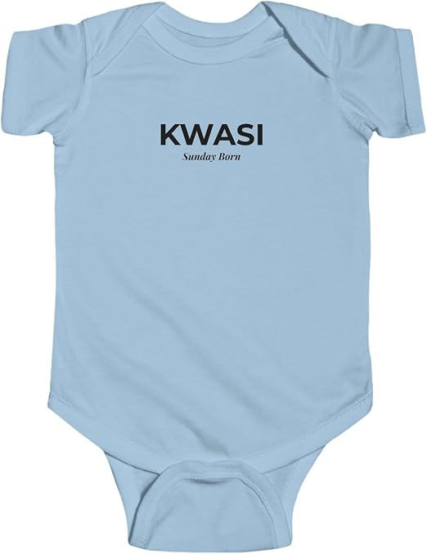
Kwesi onesie
https://www.amazon.com/dp/B0H5BV7MD3?th=1&psc=1
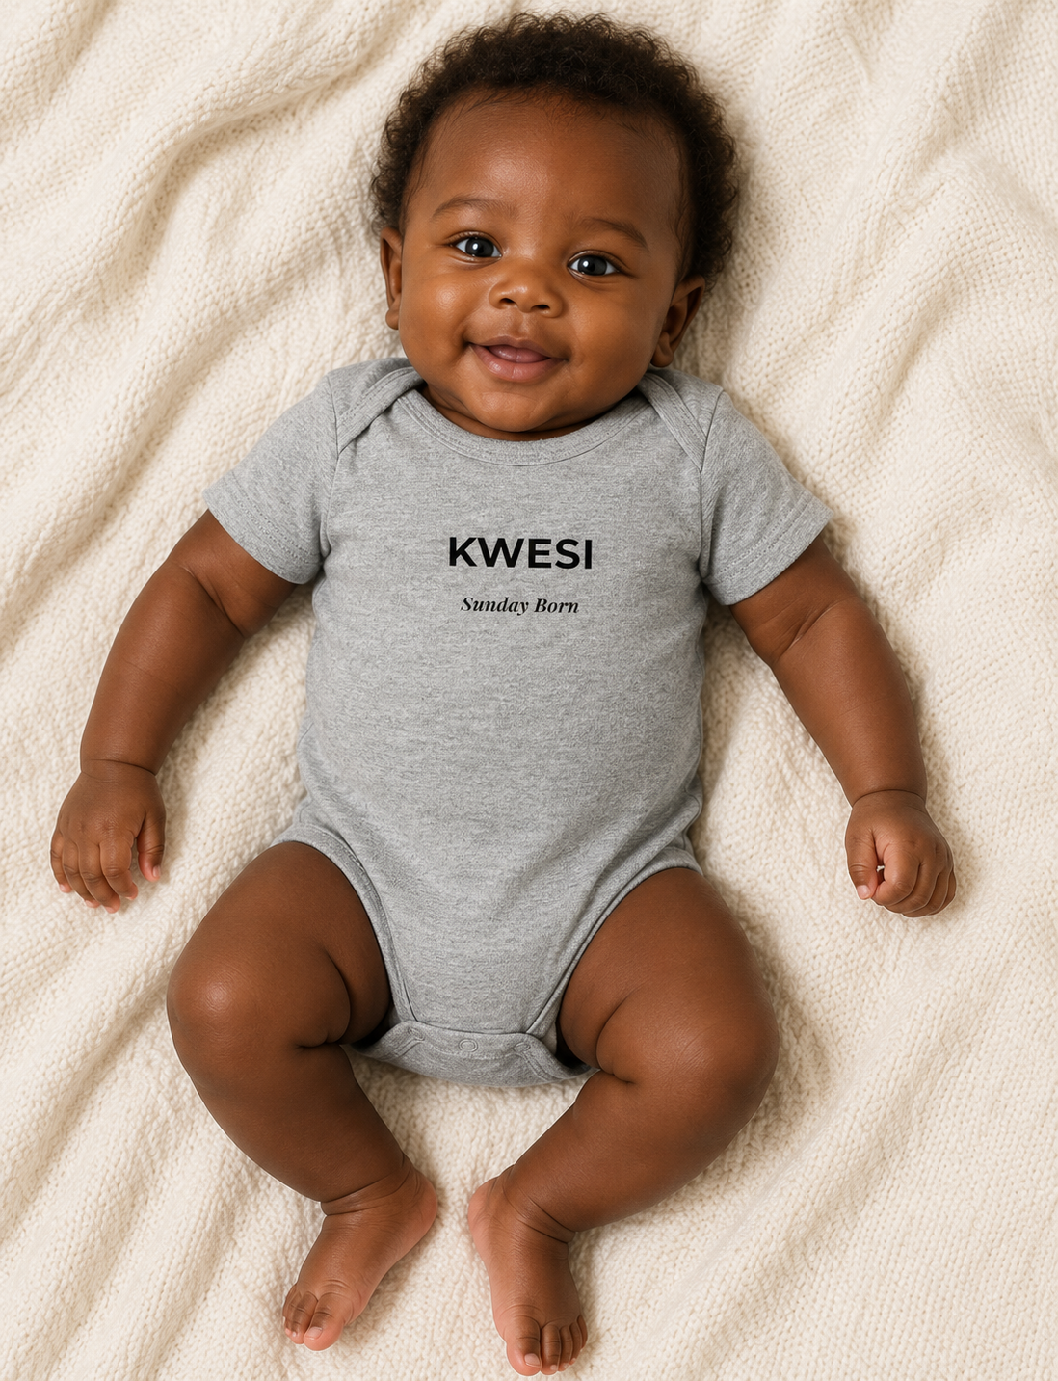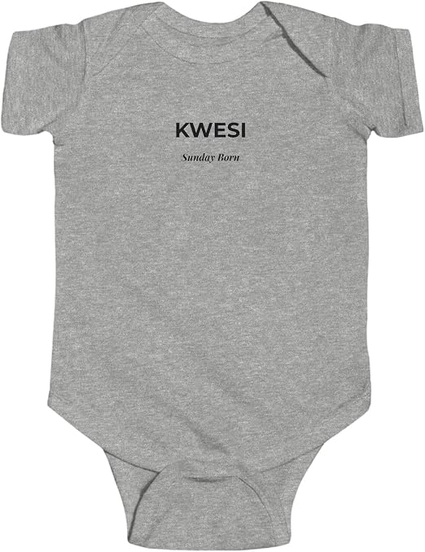
Kwesi Gye Nyame Back
https://www.amazon.com/dp/B0H3J8H89G?th=1&psc=1
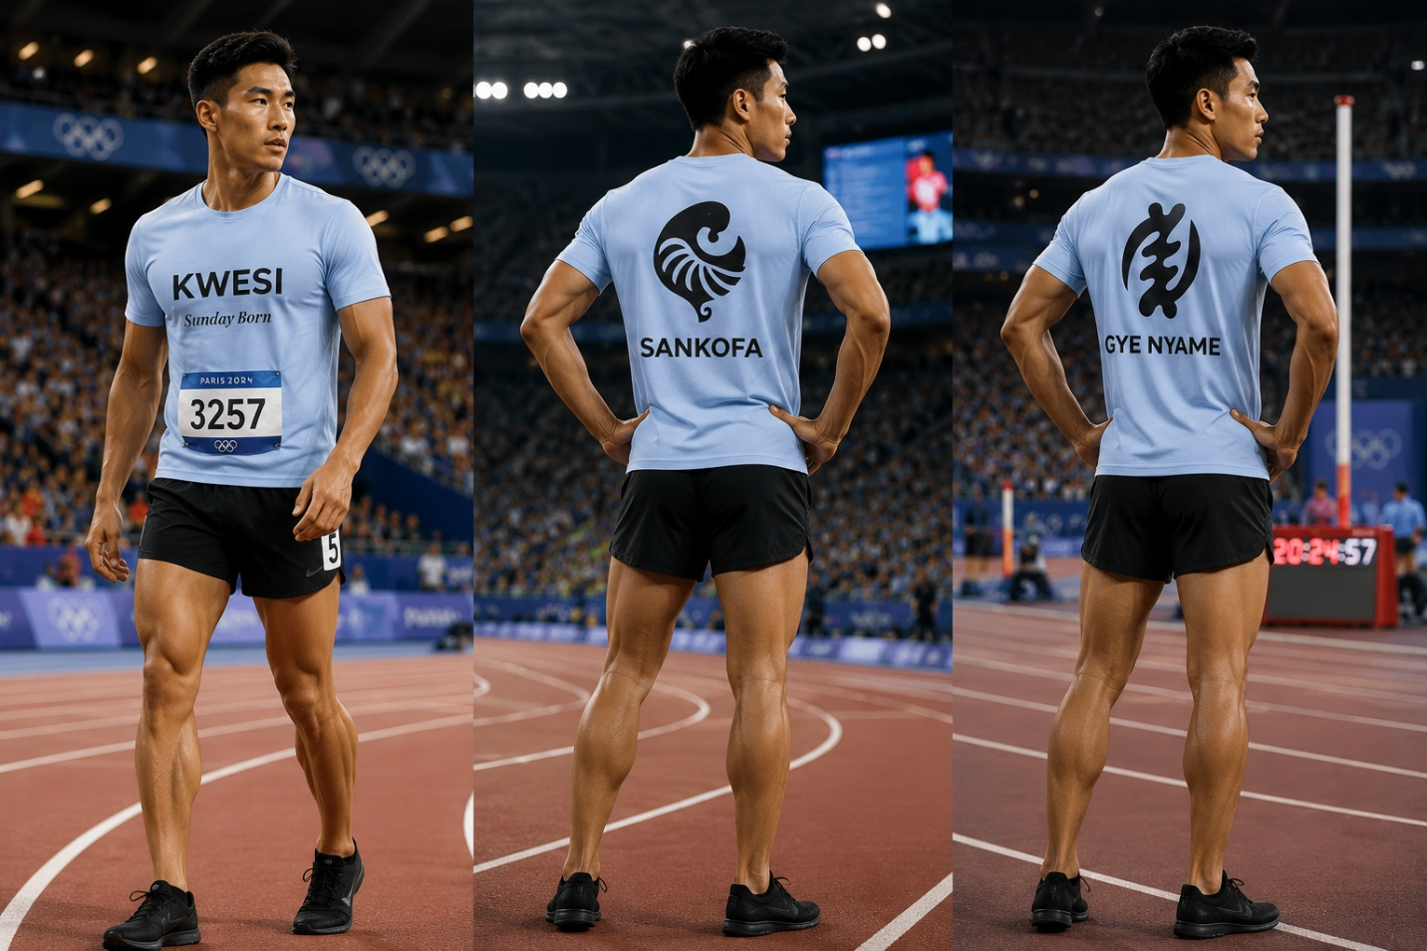

Kwesi Sankofa Back
https://www.amazon.com/dp/B0H3J2Z4HP?th=1&psc=1

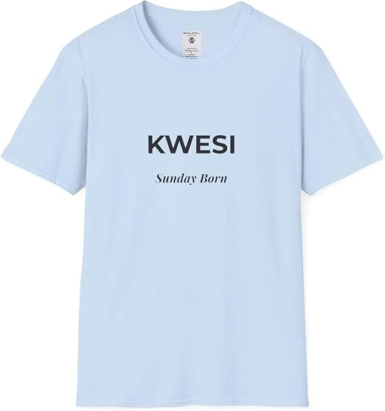
Kwasi Gye Nyame Back
https://www.amazon.com/dp/B0H3RJ79NN/ref=twister_B0H3R54CPH?_encoding=UTF8&th=1&psc=1
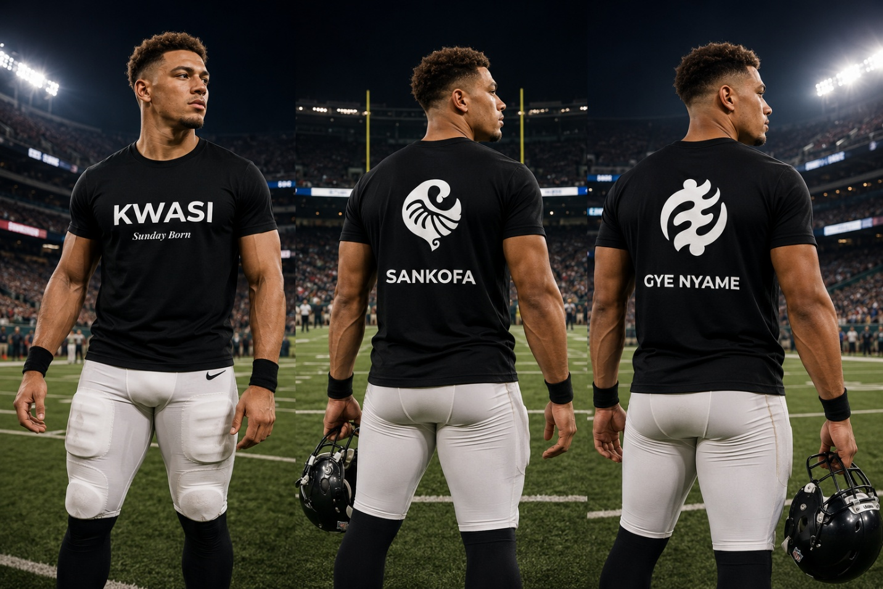
Kwasi Sankofa Back
https://www.amazon.com/dp/B0H3RDWFKR?th=1&psc=1


Akosua Sankofa Mug
https://www.amazon.com/dp/B0H5BPYLLH
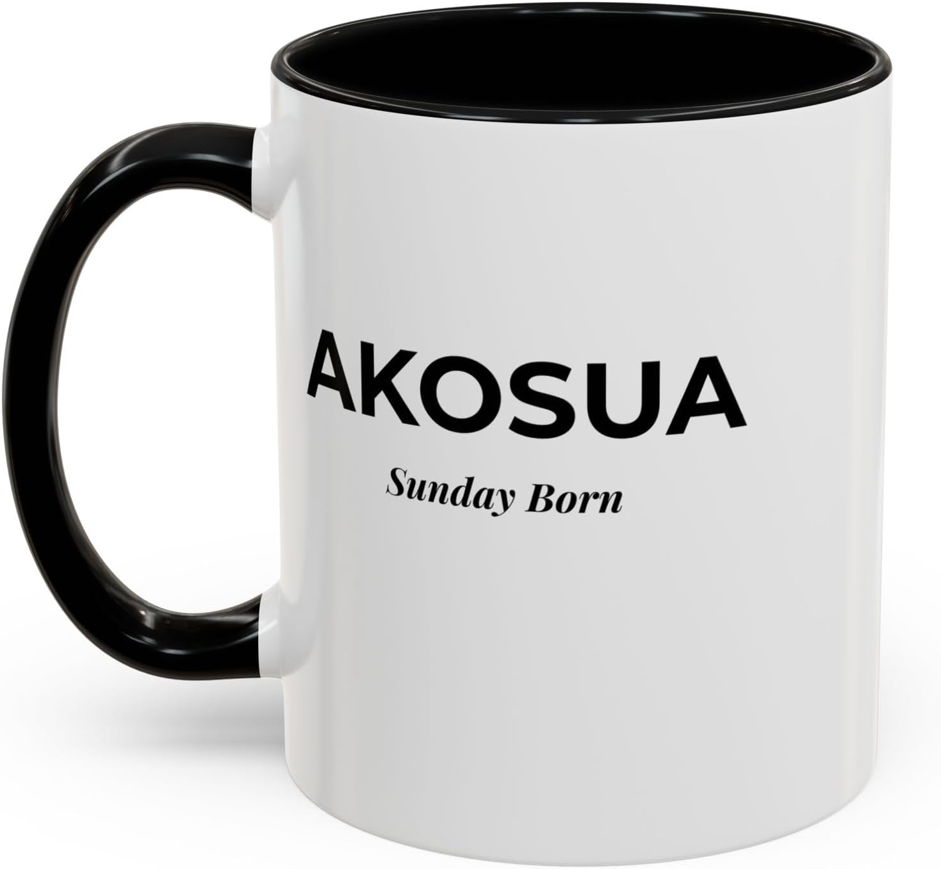
Akosua Gye Nyame Mug
https://www.amazon.com/dp/B0H5BTPKTN

can use the same images as above
Kwasi Sankofa Mug
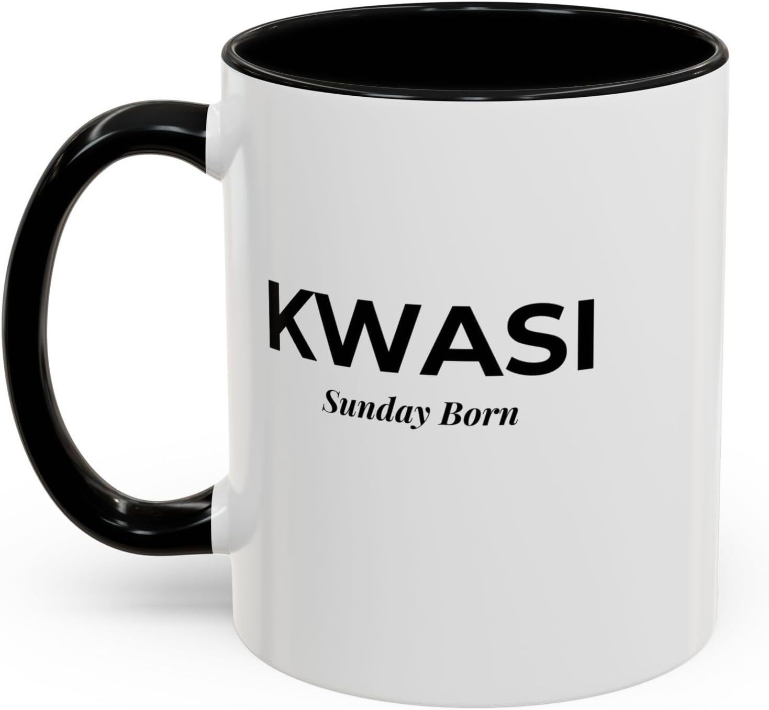
https://www.amazon.com/dp/B0H5BNJ6TL

Kwasi Gye Nyame mug
https://www.amazon.com/dp/B0H5BM1WNS

Kwesi Sankofa mug
OUT OF STOCK
Kwesi Gye Nyame mug
OUT OF STOCK

